**Weekly 4 Assessment**

**Aashika Raj**

Time: 1:30hrs Marks: 25

**Q 1. Describe linear regression and its purpose.**

**Introduce the concept of the relationship between the dependent variable and one or more independent variable (features).**

**State the linear regression equation: y = β0α + β1x + €.**

Answer: Linear regression is a statistical method to model the relationship between a dependent variable (target) and one or more independent variables (features). The primary purpose is to predict the value of the dependent variable based on the values of the independent variables. It assumes a linear relationship between the variables.

The simple linear regression equation is:

y=β0​+β1​x+ϵ

Where y is the dependent variable, x is the independent variable, β0​ is the y-intercept, β1​ is the slope, and ϵ is the error term.

**Q 2. Explain the optimization algorithm used to minimize the cost function.**

Answer: The optimization algorithm commonly used in linear regression to minimize the cost function is gradient descent. Gradient descent iteratively adjusts the model parameters (coefficients) in the direction of the steepest descent of the cost function. The goal is to find the parameter values that minimize the cost function.

**Q 3. Define he cost function (Mean Squared Error, MSE) : Ϳ (βο,β₁)=⅟n ∑ⁿ**

Answer: The Mean Squared Error (MSE) is a cost function that measures the average of the squares of the errors—that is, the average squared difference between the actual values and the values predicted by the model.

The MSE cost function is defined as:

J(β0​,β1​)=1/n ∑ni=1​ (yi​−(β0​+β1​xi​))2

Where n is the number of data points, yi​ is the actual value, and (β0​+β1​xi​) is the predicted value.

**Q 4. Describe the gradient descent update rules. Describe the gradient descent update rules.**

Answer: The gradient descent update rules for simple linear regression are:

β0​:=β0​−α (​∂J​/∂β0)

β1​:=β1​−α (​∂J​/∂β1)

where α is the learning rate, and ∂J​/∂β0 and ∂J​/∂β1 are the partial derivatives of the cost function with respect to β0and β1​, respectively.

The learning rate α determines the size of the steps taken towards the minimum. A small learning rate may result in slow convergence, while a large learning rate may overshoot the minimum.

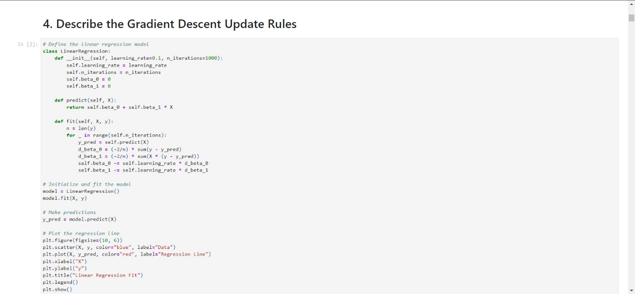

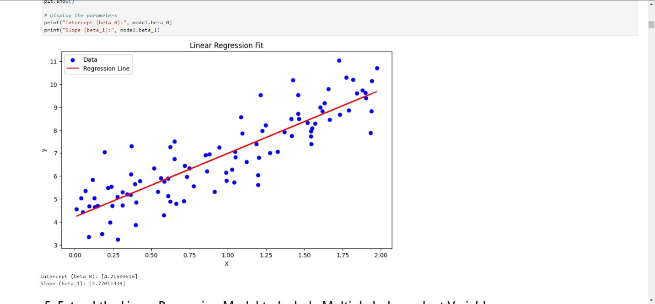

**Q 5.Extend the linear regression model to include multiple independent variables.**

Answer: For multiple independent variables, the regression equation is extended to:

y=β0​+β1​x1​+β2​x2​+⋯+βn​xn​+ϵ

where y is the dependent variable x1​,x2​,…,xn​ are the independent variables, β0​,β1​,β2​,…,βn​​ are the coefficients, and ϵ\epsilonϵ is the error term.

These answers provide a brief and simple explanation of the key concepts in linear regression.